Version with personal social buttons:

 | Darth Vader  Assistant to the Emperor  OpenTeams | AI for everyone.  m: +1 332-847-8270  w: www.openteams.com  e: anakin@openteams.com  

Version with company social buttons:

Darth Vader
Assistant to the Emperor
OpenTeams | AI for everyone.
m: +1 332-847-8270
w: www.openteams.com
e: anakin@openteams.com
Follow us:


How to update your signature in Gmail:

Click on Settings
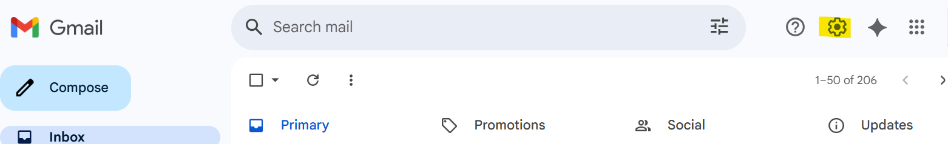

Click on See all settings
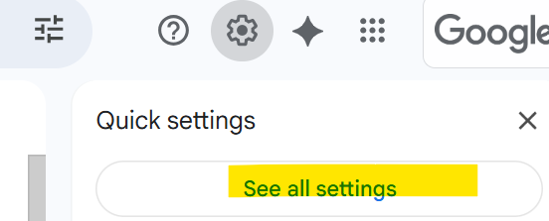

In the General tab, scroll down to Signature

Click on the pencil and name your signature.

Copy and paste the draft signature into the box on the right.
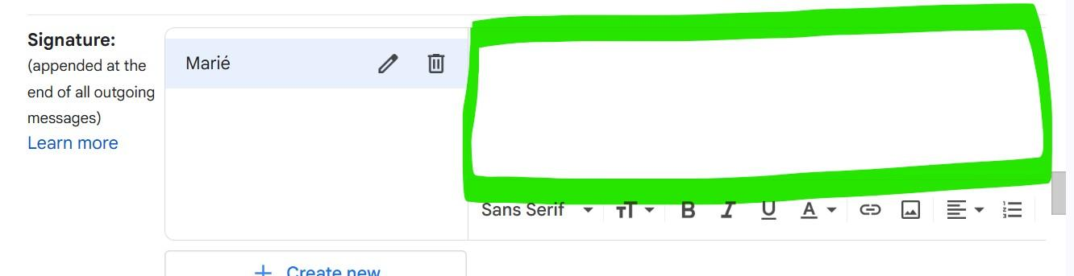

Make edits and personalize it with your name, title, email address, and phone number.

Each Icon is already linked to the company page. If you would like to change the link to your page, click on the icon and click on change and replace the URL to your links. 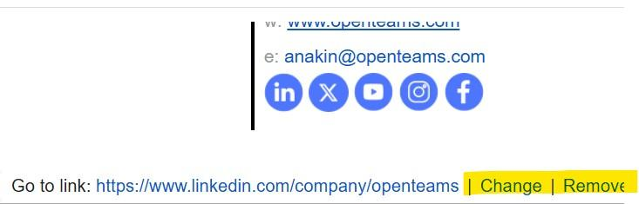

Make sure you select your signature defaults.

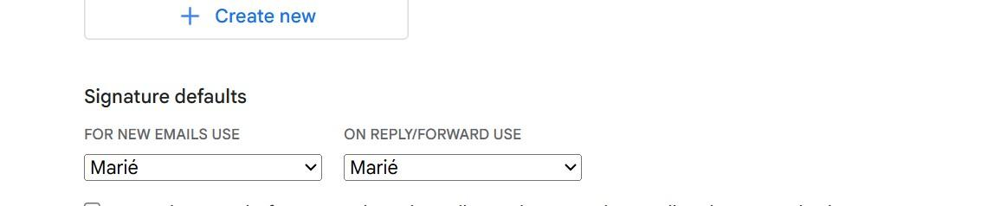

And scroll all the way down to save your changes.



You should now be all set with a branded email signature.


